Supplementary Table 1 Evaluation criteria for bacterial antibiotic sensitivity
Note: Collected from CLSI VET03/04

Drugs | Concentration μg/disc | Interpretive Categories and Zone Diameter Breakpoints, nearest whole /mm
Drugs | Concentration μg/disc | S | I | R
Norfloxacin | 10 | ≥17 | 15-17 | ≤14
Ciprofloxacin | 5 | ≥21 | 16-20 | ≤15
Enrofloxacin | 5 | ≥23 | 18-22 | ≤17
Ceftazidime | 30 | ≥21 | 18-20 | ≤17
Tetracycline | 30 | ≥19 | 15-18 | ≤14
Doxycycline | 30 | ≥14 | 11-13 | ≤10
Oxytetracycline | 30 | ≥19 | 15-18 | ≤14
Kanamycin | 30 | ≥18 | 15-17 | ≤14
Gentamicin | 10 | ≥18 | 15-17 | ≤14
Erythromycin | 15 | ≥23 | 14-22 | ≤13
Amoxicillin | 10 | ≥20 | 17-19 | ≤16
Sulfadiazine-Trimethoprim | 25 | ≥16 | 11-15 | ≤10
Florfenicol | 30 | ≥18 | 14-17 | ≤13

Supplementary Figure 1. Physical characteristics of bacteria.

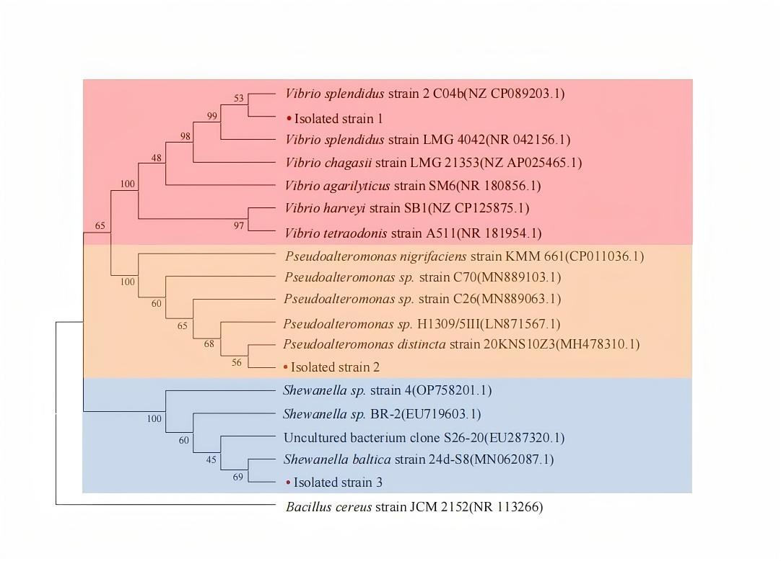
Supplementary Figure 2. The phylogenetic tree following blasting the 16S rRNA gene sequence of the isolated strain with other homologous sequences available in GenBank using a Neighbour-Joining method.

Supplementary Figure 3. Bacterial growth curves for Isolated strain 1, Isolated strain 2 and Isolated strain 3. Growth curves of Isolated strain 1, Isolated strain 2, and Isolated strain 3 were determined by culturing the bacteria in 2216E broth at 15 °C with constant agitation (150 rpm) for 16 h. Optical density at 600 nm (OD₆₀₀) was measured at 1h intervals to assess bacterial growth dynamics. Data represent the mean ± standard deviation (SD) of three biological replicates. Statistical analysis was performed using one-way ANOVA, followed by post-hoc Tukey's test for multiple comparisons. Significant differences are indicated by asterisks (*p < 0.05; **p < 0.01)

