Supplements
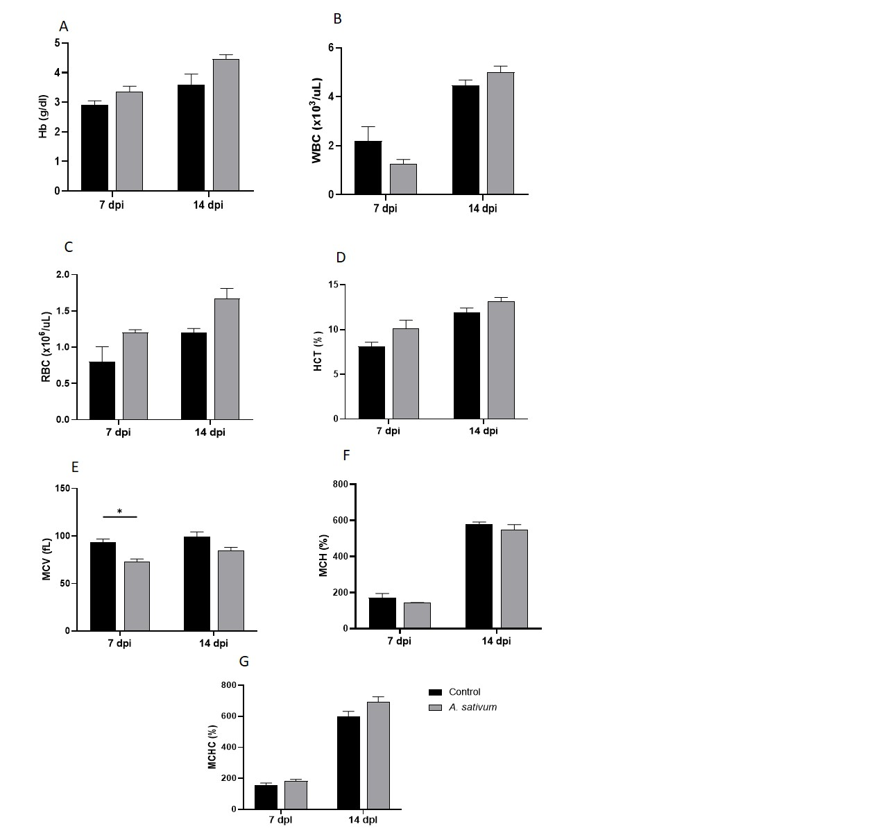

FIGURE 1. (A-G) Hematological indices of control and A. sativum treated group at 7 and 14 dpi, (A) Hb (g/dl), (B) WBCs (×10³/µL), (C) RBCs (×10⁶/µL), and (D) HCT (%), (E) MCV (%), (F) MCH (%), (G) MCHC (%).
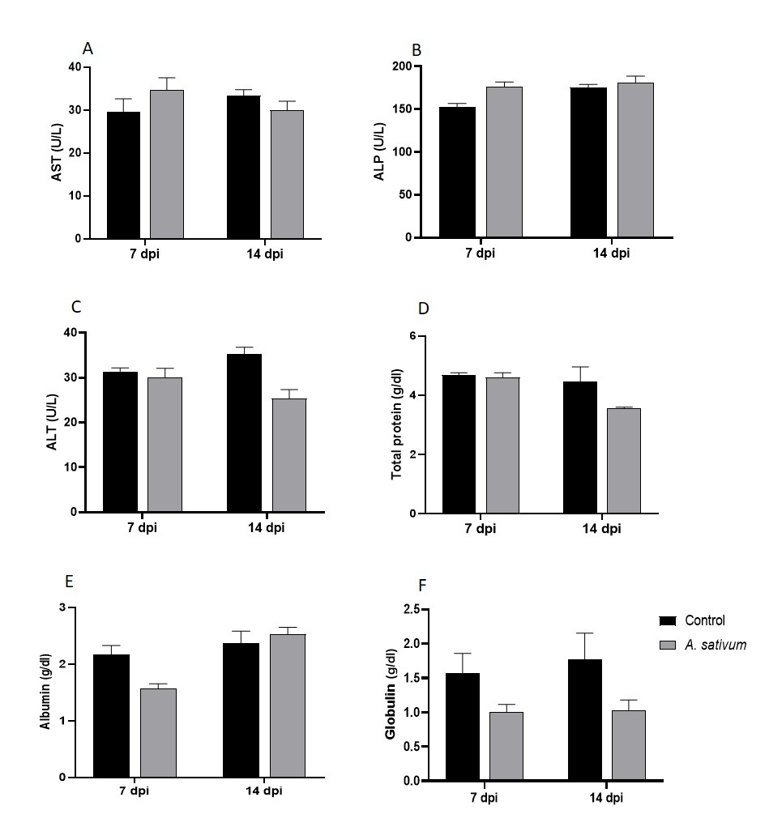
FIGURE 2. (A-F) Biochemical analysis of control and A. sativum treated group at 7 and 14 dpi, (A) AST, (B) ALP, (C) ALT, (D) Total protein, (E) Albumin, and (F) Globulin levels.
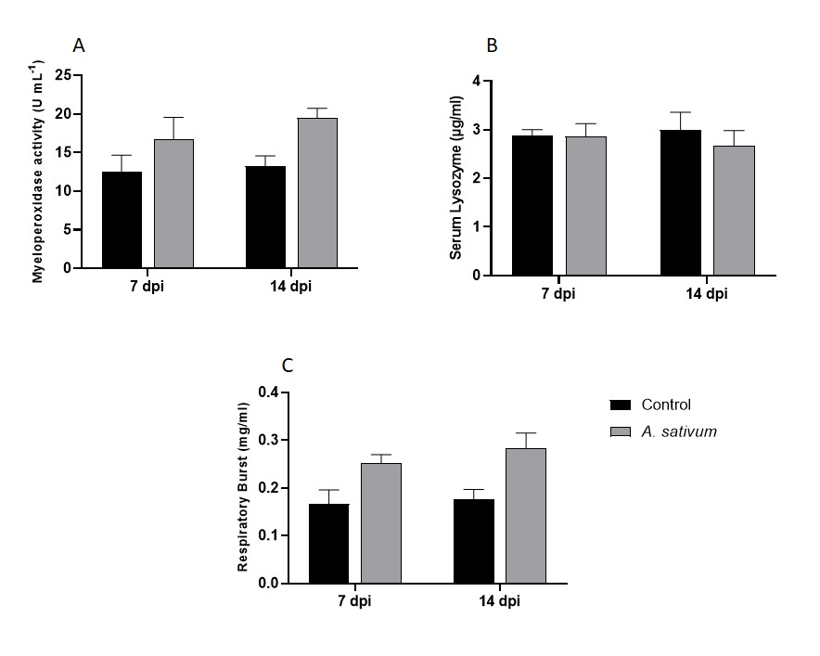
FIGURE 3. (A-C) Immune responses in control and A. sativum treated group at 7 and 14 dpi, (A) Myeloperoxidase Activity, (B) Serum Lysozyme, and (C) Respiratory Burst.

